Do While loop

Workshop #2

Flutter Developer Bootcamp

# **Purpose**

This workshop demonstrates the use of a do-while loop to sequentially print numbers from 0 to 10.

**Problem**

In the given workshop demonstrates how to use a do-while loop to print numbers from 0 to 10 sequentially. It starts with number initialized to 0 and continues printing and incrementing number until it reaches 11, terminating the loop. This demonstrates the unique feature of do-while loops where the loop body executes at least once before checking the loop condition for subsequent iterations.You need to print numbers from 0 to 15 sequentially.

**How to Solve**

1. Checkout the workshop from Git Repo:

git clone -b <user-branch> <repo-URL>

1. Open the root folder inside VS Code
2. Open the root folder in terminal
3. Run the command dart run filename.dart
4. Initializing a variable (number) to start the sequence at 0.
5. Using a do-while loop to repeatedly print and increment number until it reaches 15.
6. Printing each number sequentially using the print function.
7. Automatically terminating the loop when number exceeds 15, based on the loop condition.
8. Go To File: <specific-file--method> à <method-name>, implement your logic.

**You will Achieve**

When you complete this workshop you will learn the following:

**Methods and Functions Used:**

* **main() Function:**
* Entry point of the Dart program where execution begins.
* Takes no arguments (void main() signifies no return value and no parameters).
* **print() Function:**
* Used to output each number (print(number)) to the console sequentially.
* Demonstrates how to display information during program execution.
* **Increment Operator (++):**
* number++ is used to increment the value of number by 1 after each iteration of the loop.
* Essential for controlling the loop's progress and ensuring it terminates correctly (number <= 15 condition).

# **Screenshots**

## **Before implementation (without printing 15 numbers)**

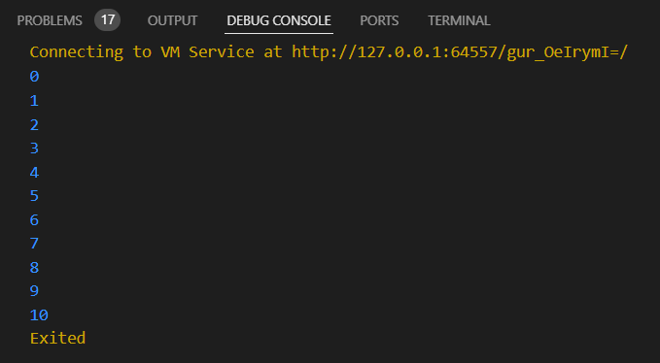

## **After implementation (with printing 15 numbers)**

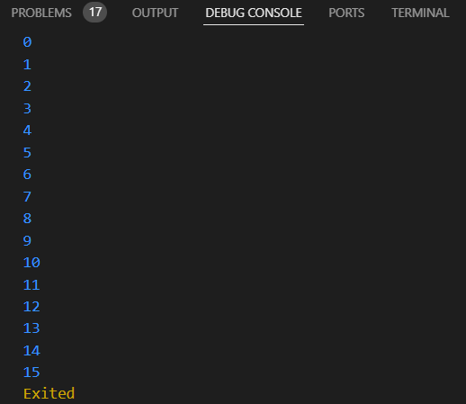

# **How to submit your workshop**

Push your project back to the same git branch using command:

<command name>

# **Happy Coding!**